**Experiment 1.3**

Student Name: Vivek Branch: CSE

UID: Section/Group:

Date of performance: 30/08/2022 Subject name: OOPs Using JAVA

Semester: 3rd Subject Code: 21CSH-218

**AIM:** In this problem, we populated an ArrayList in main() method with several instances of the classes - Student, Rockstar, and Hacker. The count() method calculates how many instances of each type is present in the ArrayList. The code prints three integers, the number of instances of Student class, the number of instances of Rockstar class, and the number of instances of Hacker class.

OBJECTIVE:

To Understand the concepts of ArrayList and functions of ArrayList in Java.

PROGRAM CODE:

import java.util.*;

class Student{}

class Rockstar{ }

class Hacker{}

public class InstanceOFTutorial{

static String count(ArrayList mylist){

int a = 0,b = 0,c = 0;

for(int i = 0; i < mylist.size(); i++){

Object element=mylist.get(i);

if(element instanceof Student)

a++;

if(element instanceof Rockstar)

b++;

if(element instanceof Hacker)

c++;

}

String ret = Integer.toString(a)+" "+ Integer.toString(b)+" "+ Integer.toString(c);

return ret;

}

public static void main(String []args){

ArrayList mylist = new ArrayList();

Scanner sc = new Scanner(System.in);

int t = sc.nextInt();

for(int i=0; i<t; i++){

String s=sc.next();

if(s.equals("Student"))mylist.add(new Student());

if(s.equals("Rockstar"))mylist.add(new Rockstar());

if(s.equals("Hacker"))mylist.add(new Hacker());

}

System.out.println(count(mylist));

}

}

OUTPUT:

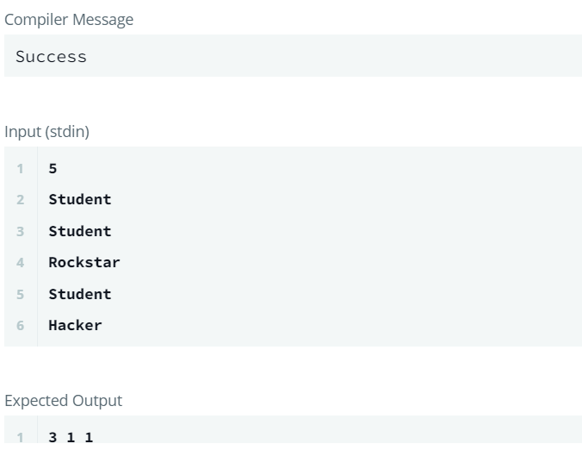

**Learning outcomes (What I have learnt):**

1. We have learned about instanceof in Java.
2. We have learned how to use instanceof in different programs in Java.
3. We have learned about how to apply mathematical logic in instanceof in Java.